Polamraju Sai Nithin

CH.EN.U4CSE20052

DISCORD HANDLE: **sai nithin#7018**

**TASK – 1 [GIT & GITHUB]**

**# CREATING A GITHUB ACCOUNT**

--> I have already created a GITHUB account.

**# INSTALL GIT IN YOUR DESKTOP**

--> GIT is already installed on my PC.

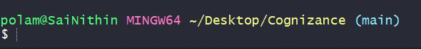

**1. Create a repository with name “Cognizance” on GitHub using Git Bash.**

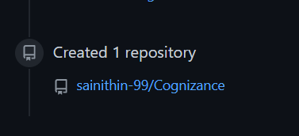

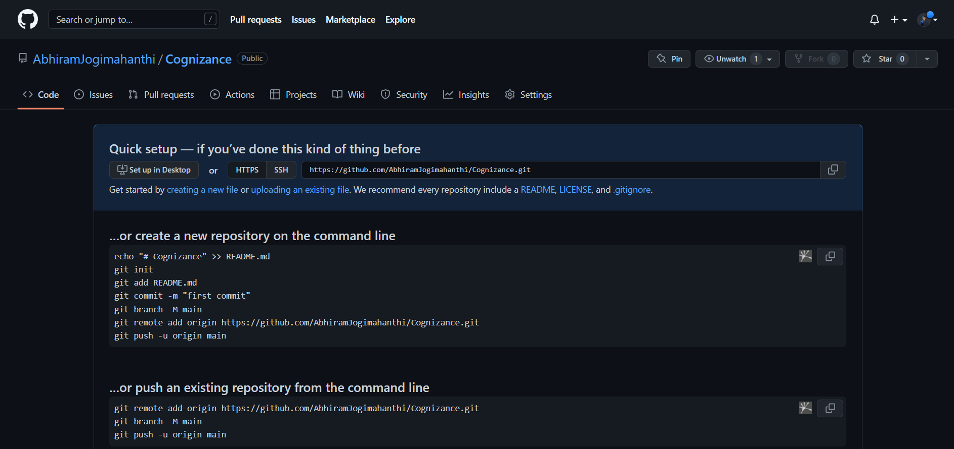

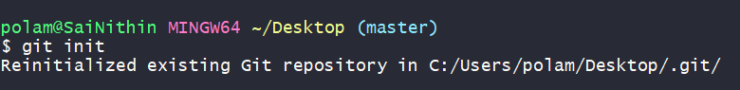

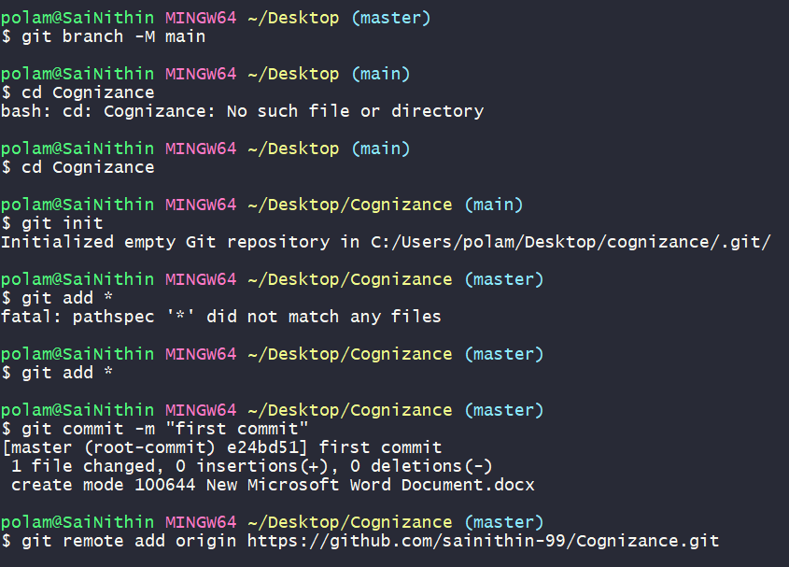

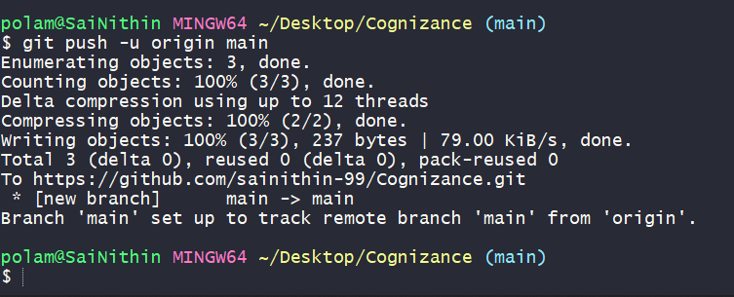

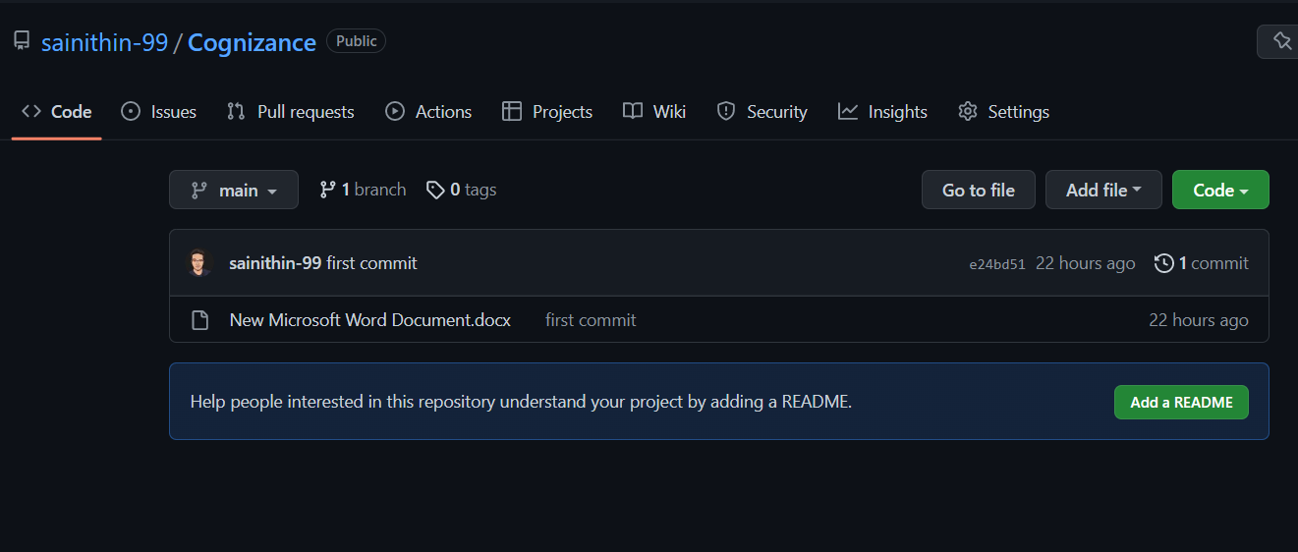

**2. Create a folder with name “Task-1” in the repository and perform the Git operations using Git Bash.**

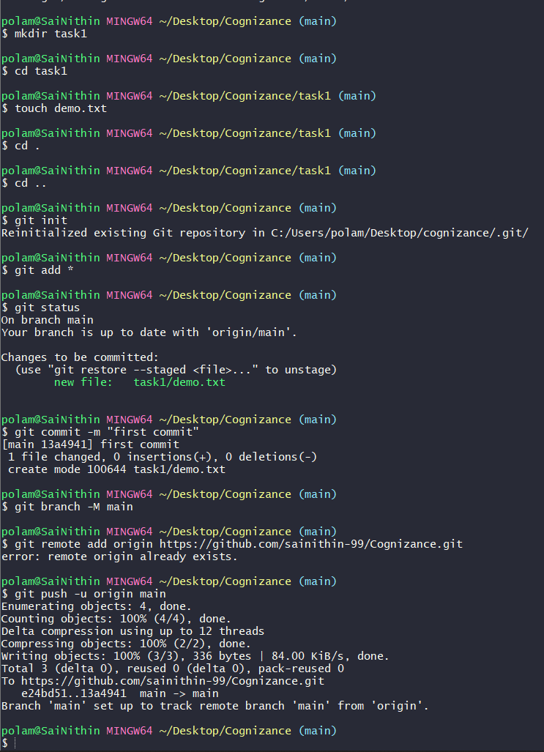

**3. Upload the screenshot of the git bash using This command in your computer.**

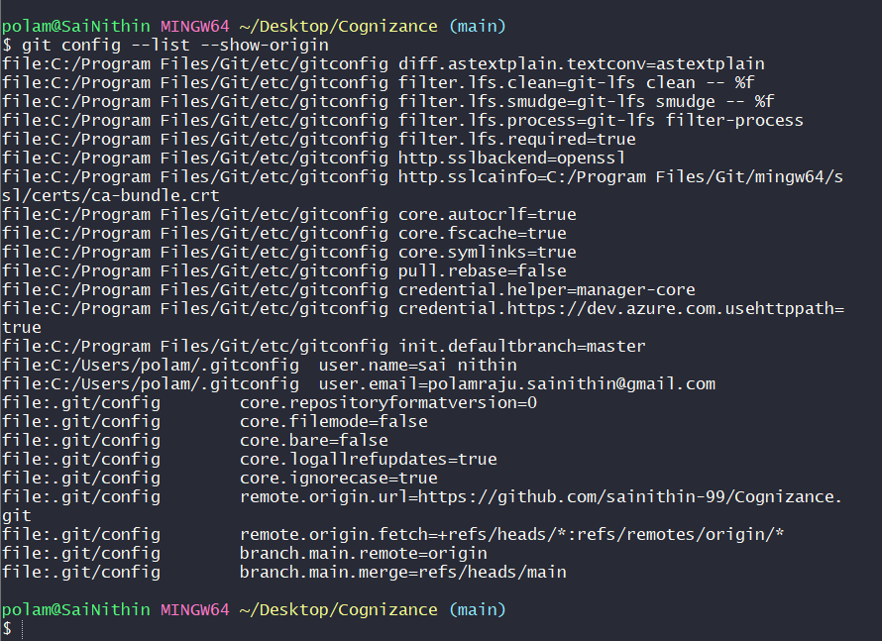

**4. Take a screenshot of all the Git operations you performed and compile it in a single PDF and upload it in “Task-1” folder this PDF Should Also Contain the screenshot of the command mentioned in point 3.**

**GIT ADD:**

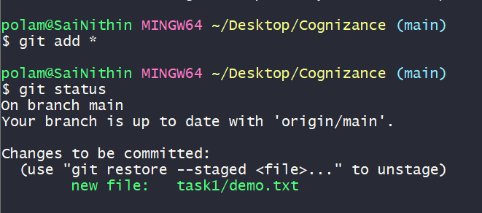

**GIT CHECKOUT:** Replaces the current working files with files from a branch.

**GIT CHECKOUT-B:** Creates new local branch from the current branch’s tip.

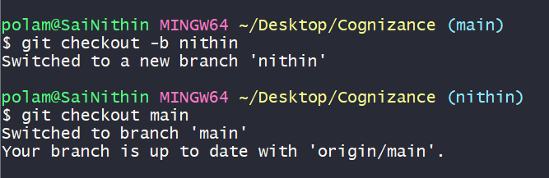

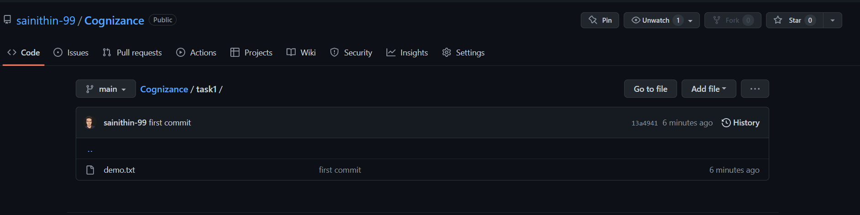

**GIT PUSH:**

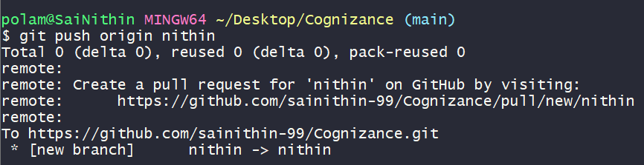

**GIT PULL:**

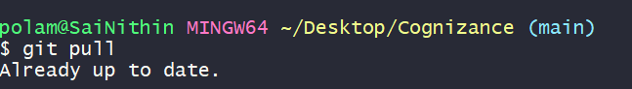

**GIT COMMIT:**

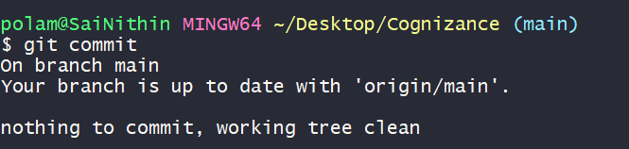

**GIT COMMIT –A:**

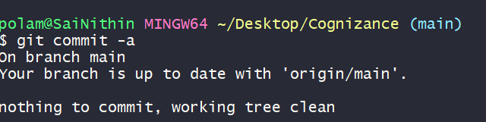

**GIT FETCH:**

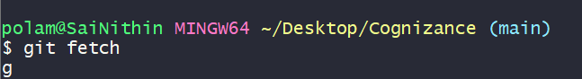

**GIT MERGE:**

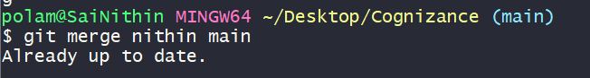

**GIT CLONE:**

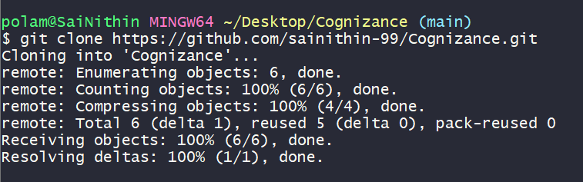

**GIT RESET:**

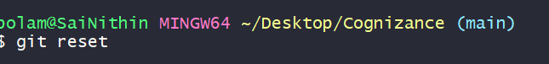

**GIT REBASE:**

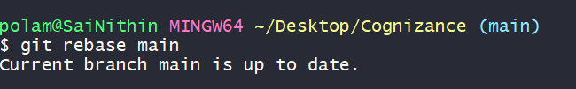

**GIT FORK:** Fork will create a copy of the repository in your GitHub account so that you can make changes to the project.



